**Zendesk Apps Tool**

Installing & Building Documentation

**Zendesk Apps Tools** [1](https://docs.google.com/document/d/1u6vfNHefWjvZ5ursBY0GK-ksFzdAuuq4676iZy39MXc/edit#heading=h.gjdgxs)

Introduction [3](https://docs.google.com/document/d/1u6vfNHefWjvZ5ursBY0GK-ksFzdAuuq4676iZy39MXc/edit#heading=h.1fob9te)

Installing ZAT Tool 4

Creating App 4

Project Structure 5

Explanation of Code 6

Core Concept 8

Public Domain 8

Packaging and Installing 9

**Introduction**

This documentation will explain some steps in term of building and installing Zendesk App on Zendesk Support Page based on what writer already experienced of it. You will not find detail explanation for each steps provided in this documentation since the detail one is easily accessible on the official documentation of Zendesk. You can access it. However, the writer will still provide related link of the official documentation for each step the writer explains so it should be easier and applicable for any reader who follows this documentation.

After you finish all the steps guided in this documentation, supposedly you will see your simple app in the right-side of Zendesk Support Page as you can see in the screenshot provided below. The app the writer built is named ‘Arisan-Zen App’.

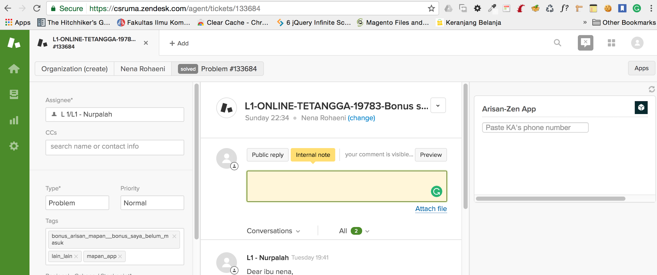

Now, let us go on to the next section.

**Installing ZAT Tool**

Zendesk Apps Tool (ZAT) is a kind of tool officially provided by Zendesk to build a simple useful app, iframe app actually, that will be displayed on the Zendesk Support page. The way to build an app through this tool is very easy. I guarantee it. If you are MAC users, you need to set up ZAT in your local environment by following these steps first:

1. Installing Ruby
2. Installing Rake (a build automation tool)
3. Installing ZAT tool
4. Updating ZAT tool

You will find that the steps mentioned above really easy to follow especially for MAC users. Before you follow the steps, please go on to the next section first.

**Creating App**

After the installation process of ZAT tool succeed, the tool will let you do the following:

1. Create all needed files for building a simple useful app
2. Run ZAT server and test the app locally in a browser
3. Validate your app from any error or bug
4. Package your app for uploading to Zendesk Support page

What is more interesting for the writer is we can locally run our app directly on the Zendesk page by only appending ?zat=true to the Zendesk url. For example:

https://csruma.zendesk.com/agent/tickets/321?zat=true

It works, of course, after the Zendesk server is properly running on local.

To see more detail steps, you can refer to this official documentation link talking about installing and using the Zendesk Apps Tools:

<https://help.zendesk.com/hc/en-us/articles/229489288#topic_dhg_35m_1l>

Follow the steps right now before going to the next section!

**Project Structure**

After the installing process succeed, the first thing to know before you start building an app is to know how the project structure exactly is. In my own app, the project structure is quite simple and understandable as shown below:

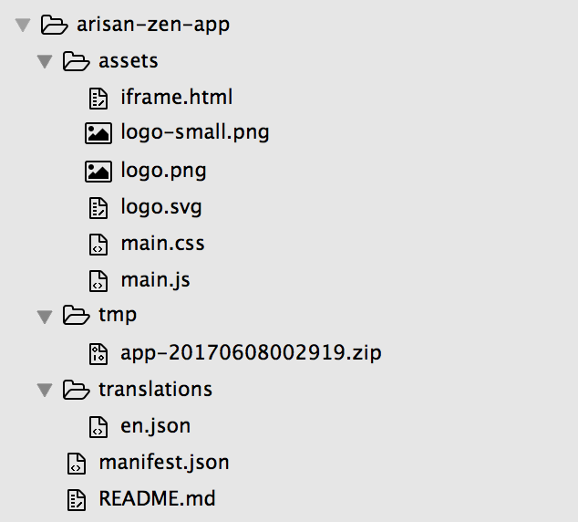

Simply, the structure is quite simple. The important files to know is firstly iframe.html file. A Zendesk app lives in an iframe in the product. Like any iframe app, developing a Zendesk app consists of combining static and dynamic elements in the HTML file to be displayed in the iframe. To do so, any adjustment should be in this file. It is automatically created by Zendesk App tool. You can review it directly in your own text editor. If you want, and that is what I also did, you can call third-party libraries like bootstrap, jquery and handlebars.js as template engine within this file.

Secondly, main.css and main.js file. I manually created it in assets folder. As widely known, these two files is to separately write stylesheet and script needed in certain project.

The third is logo.png and logo.svg, you can replace it with the new one you expect as your project icon.

The next is manifest.json as the whole information and configuration for your app.

And the last but foremost is app-xxxx inside tmp folder. This one is a package that would be uploaded and installed on the Zendesk Support page. You can generate it by Zendesk tool at the moment you finish the building process.

For more information about this, you can refer to this link talking about the building of Zendesk app:

<https://help.zendesk.com/hc/en-us/articles/229137287>

Now, we will go on to the most challenging part of this documentation. Which is talking deeply about the code the writer used to build `Arisan-Zen App`. Come on!

**Explanation of the code**

The main and only feature of the writer’s app is to fetch all KA data by passing KA’s phone number in order to be consumed by the related API. The first concept to know that Zendesk provide the way to utilize Core API provided by Zendesk itself and to utilize API from any external resource, which is for this case I utilized the existing Arisan API built inside View Midware of Ruma.

For the first facility of using Core API provided by Zendesk, the writer will not talk too much about this. You can refer to the related link below. You know, so many thing you can do in order to manipulate all data provided on Zendesk App like satisfaction ratings, ticket comments, ticket statues, users, groups, tags and so forth. Kindly check the link.

<https://developer.zendesk.com/rest_api/docs/core/introduction>

Then in case you want to manipulate the data of user object, it is thoroughly explained in this below documentation.  
  
<https://developer.zendesk.com/apps/docs/agent/data#user-object>

For the second facility of utilizing external resource API, please first see the screenshot of the writer’s code below.

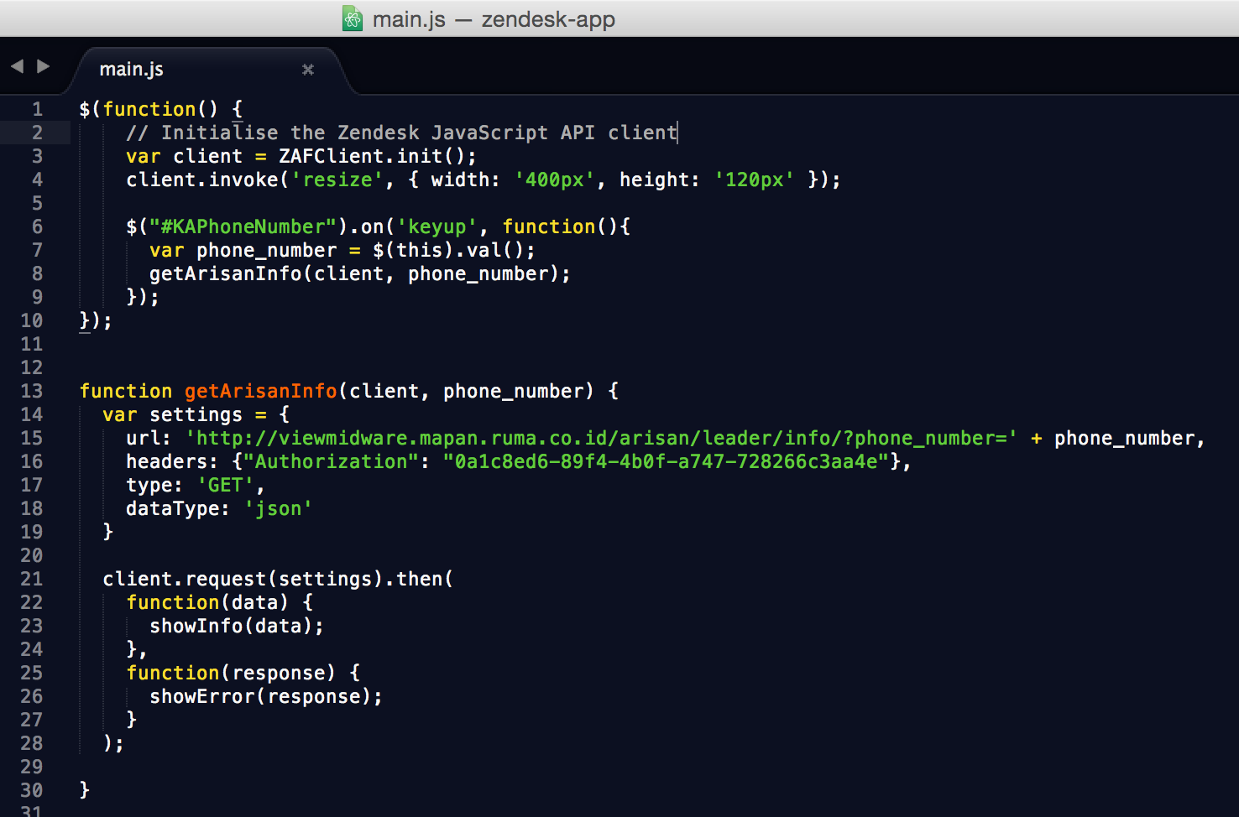

In your project you automatically include the ZAT SDK, by this, you get access to the ZAFClient object. The statement below returns a client object.

var client = ZAFClient.init();

There are methods of client object that can be used with their each function, for example above, the writer uses .invoke() method to execute `resize` action. Also, the writer uses .request() method to do HTTP request. You can check link below for more explanation about this.

<https://developer.zendesk.com/apps/docs/apps-v2/api_reference>

Then, the writer uses JQuery method in this app, which is `on` to execute `keyup` action and then execute getArisanInfo() function insides. The function runs the main process of this app by calling the API for fetching all KA data by KA’s phone number. On the settings block, the writer provides header params as authorization matter. This is important concept to understand. I think, you have to read more about this concept by moving on to the next section.

**Core Concept**

Zendesk apps get external data by making HTTP requests. If the app makes requests to a public API that doesn’t require authentication or any other sensitive information, then you can use jQuery.ajax() or the standard XMLHttpRequest JavaScript API. However, when making AJAX requests from an app installed in a Zendesk product like Zendesk Support, the request settings can be viewed in the browser console by agents. Some settings may contain sensitive information such as an API key or token. Find it out by reading this tutorial.

<https://help.zendesk.com/hc/en-us/articles/229489168-Zendesk-Apps-tutorial-Getting-data-from-an-external-application>

**Public Domain**

Note that internal IP Address is totally forbidden. It is not allowed by Zendesk to fetch data from internal private IP address, so that the only way we have is accessing data, in case of getting data from an external application, from the public domain the Ruma’s Tech Team have, which is *viewmidware.mapan.ruma.co.id*.

**Packing and Installing**

After you finish building your own app, then you should package and install the app. Thoroughly test your app with the ZAT tool by run this command in your console. Ensure that your position is in your root folder.

$ zat server

Then run the following command.

$ zat validate

Finally, package your app in a zip file that can be uploaded to your instance of Zendesk Support. Run this command.

$ zat package

On the manage of apps category, you can manage all app you have. In order to upload your newly built app, please click the upload button as shown on the screenshot provided below. Upload the zip file of your app and then install it!

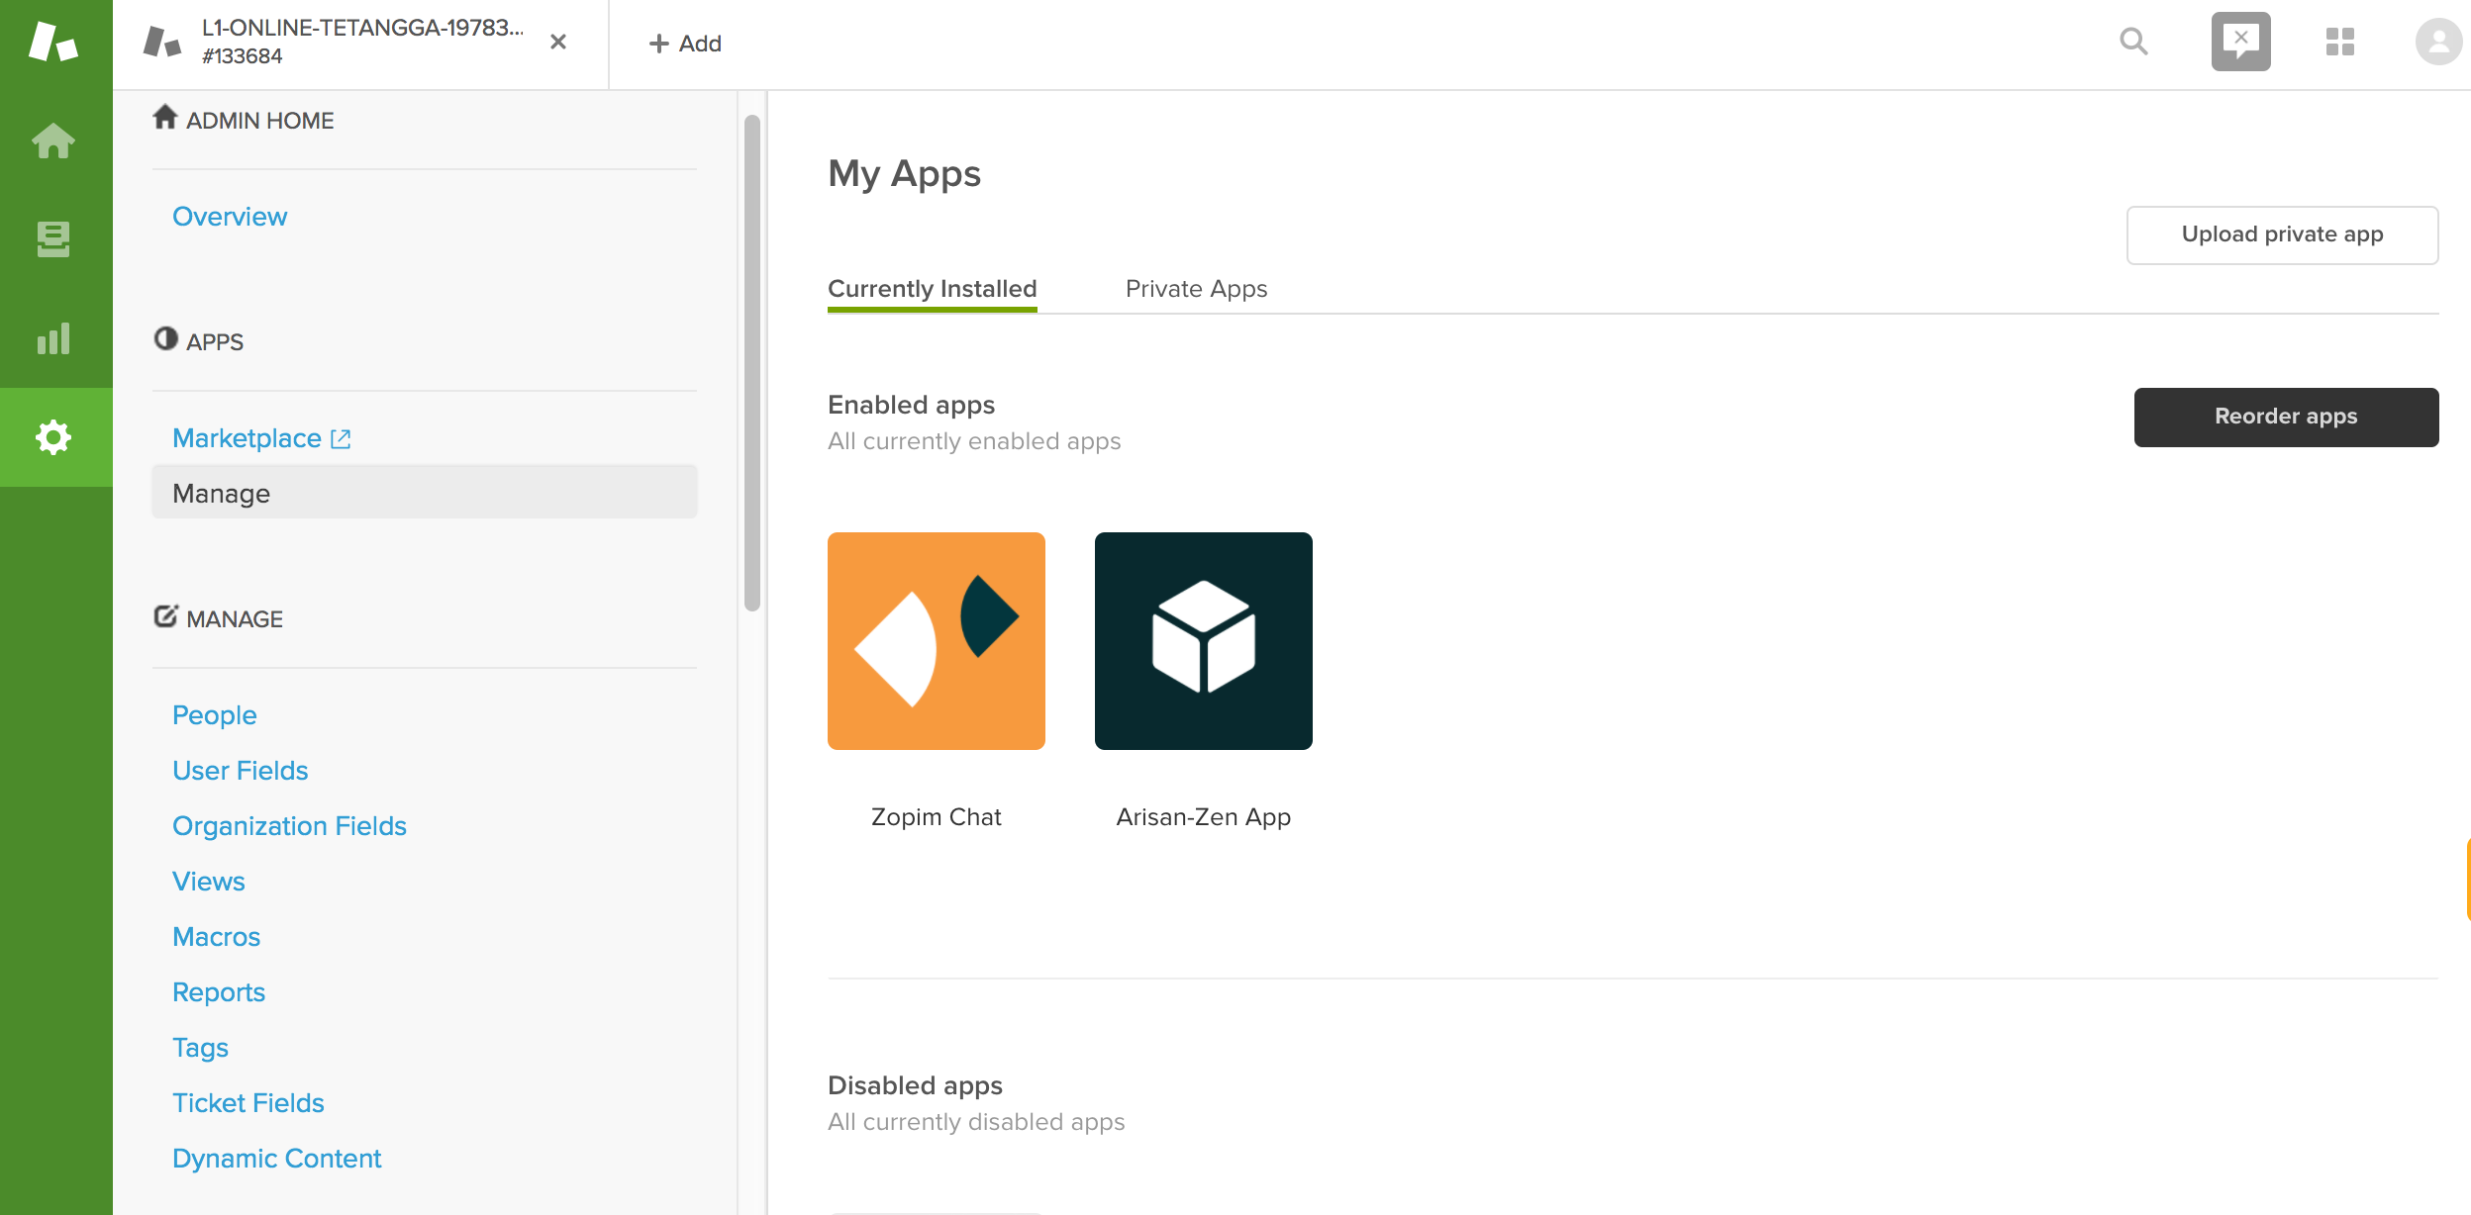

If you want to find more about this tutorial, kindly read this documentation page.

<https://help.zendesk.com/hc/en-us/articles/229137347>

That is all! I thank you so much for following these simple steps. For more information, don’t hesitate to contact me on [angga.muttaqien@ruma.co.id](mailto:angga.muttaqien@ruma.co.id)

Best regards,

Muhammad Angga Muttaqien

Jr. Software Engineer